DISCOGRAPHY VOLUME IV

- Desde El Alma (From the Soul) – Argentine Tango-vals by Osvaldo Pugliese - Instrumental

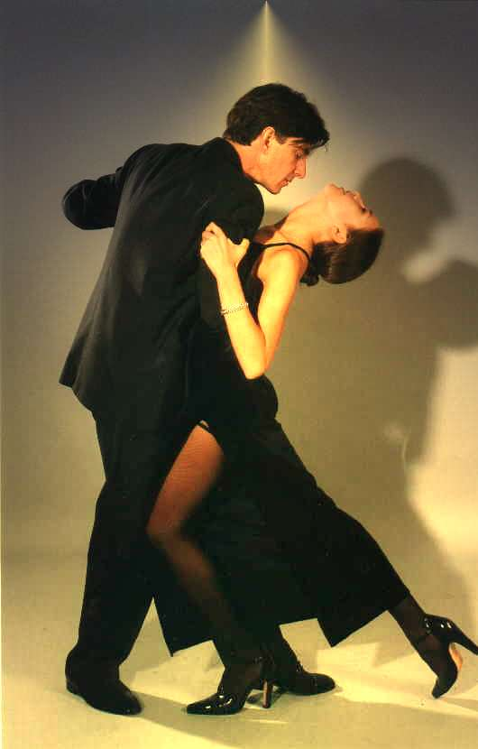

- African Tango by Adiemus - instrumental
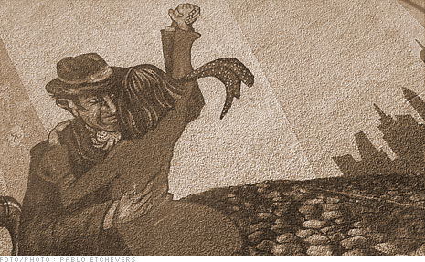

- Only Time – Enya

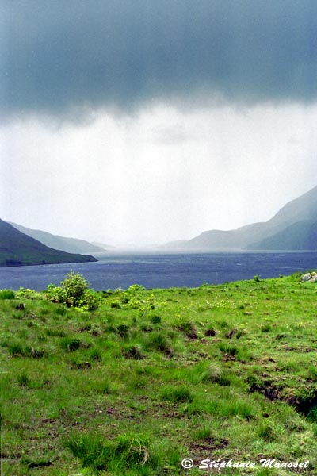
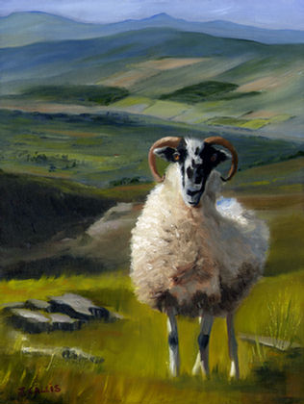
Who can say where the road goes,
Where the day flows, only time?
And who can say if your love grows,
As your heart chose, only time?
Who can say why your heart sighs,
As your love flies, only time?
And who can say why your heart cries
when your love lies, only time?
Who can say when the roads meet,
That love might be ,in your heart?
and who can say when the day sleeps,
and the night keeps all your heart?
Night keeps all your heart.....
Who can say if your love grows,
As your heart chose, only time?
And who can say where the road goes
Where the day flows, only time?
Who knows? Only time
Who knows? Only time

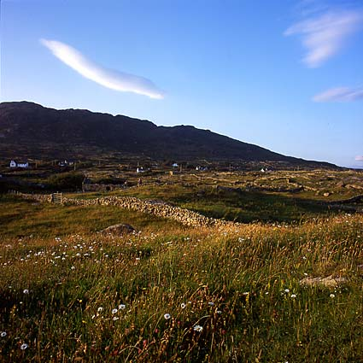

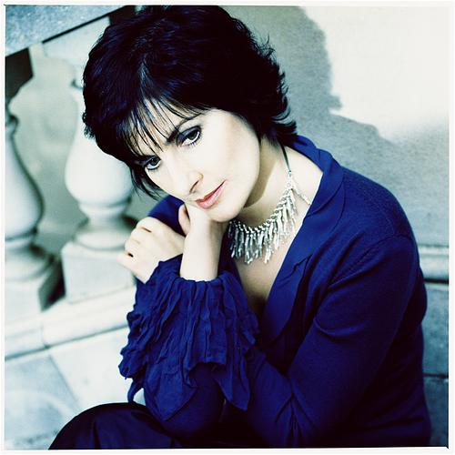

ABOUT ENYA

Musical Upbringing and Clannad
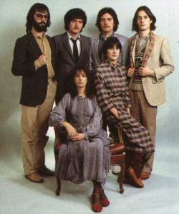
Enya was born in Gweedore, County Donegal, in Ireland in 1961 to a musical family, the fifth of nine children. Her grandparents were in a band that played throughout Ireland, her father was the leader of the Slieve Foy Band before opening a pub, and her mother played in a dance band and later taught music at the Gweedore Comprehensive School.
In 1980, Enya worked with Clannad, the band composed of her siblings Máire (Moya), Pól, and Ciarán and twin uncles Noel and Padraig Duggan, playing the keyboard and providing backing vocals although she was never officially a member of the group. In 1982, shortly before Clannad became famous for "Theme From Harry's Game," producer and manager Nicky Ryan left the group and Enya joined him to start her own solo career.

Solo career
Enya, working with Nicky and his wife Roma, was first credited as Enya (as opposed to Eithne) for writing some of the music for the 1984 movie The Frog Prince. Another early appearance on record followed in 1987, where Enya provided spoken vocals on Sinéad O'Connor's debut album, The Lion and the Cobra.
Enya was contracted to provide music for the soundtrack of the 1986 BBC television documentary The Celts. The music she produced was featured on her first solo album, Enya (1987), but it attracted little attention at the time.

International Breakthrough
Enya achieved a breakthrough in her career in 1988 with the album Watermark, which featured the hit song "Orinoco Flow" (sometimes known as "Sail Away"). "Orinoco Flow" topped the charts in the United Kingdom, and the album sold eight million copies.
Three years later, she followed with another hit album, Shepherd Moons, which sold ten million copies and earned Enya her first Grammy Award. Four years later, she released the Grammy-winning The Memory of Trees (1995).
In 1997, Enya released her greatest hits collection, Paint The Sky With Stars: The Best of Enya, which featured two new songs: "Paint the Sky With Stars" and "Only If...".

Return and 'A Day Without Rain'
Following a five-year break, she released the Grammy winning A Day Without Rain in 2000). The album is Enya's most successful to date, peaking at #2 on the US Billboard Album charts. After the September 11, 2001 attacks, her song "Only Time" (from A Day Without Rain) was used as a backdrop in many radio and TV reports about the attacks. She initially frowned upon this use, especially when many bootlegged versions of "Only Time" mixed with sound effects from the attack began to appear.
Enya is self-admittedly a slow worker when it comes to composing music. As a result, fans have had to wait as long as five years between albums. Enya was awarded the World's Best-Selling Irish Act award at the World Music Awards in London on 19 November 2006. On February 11, 2007 Amarantine won Enya her fourth Grammy when it was awarded the Best New Age Album award. In that album, Enya sings in Japanese and Loxian, a language invented by Roma Ryan. A number of Enya's songs are sung entirely in Irish or Latin, but most of her songs are sung in English. Enya has also sung songs written entirely or partially in Welsh, Spanish, French and even languages created by J. R. R. Tolkien for The Lord of the Rings.
Enya has given several live performances on various television shows, events and ceremonies but she has yet to do a concert. She has said, though, that she would love to do it some day, and would consider it to be a great challenge.
