DISCOGRAPHY – VOLUME VI
All instrumentals

- Adeline - Richard Clayderman
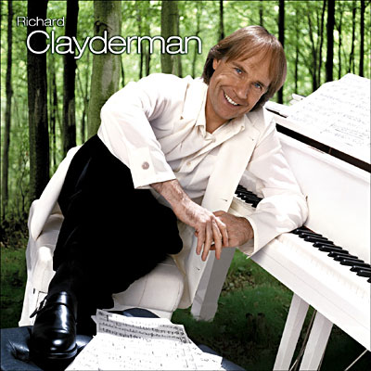

Born to a piano teacher, Clayderman started studying to play piano at age six, and he was accepted at a Conservatory of Music in Paris at age 12. After finishing Conservatory he worked as an accompanist and session musician. His life changed dramatically in 1976, when he recorded a single "Ballade pour Adeline", composed by french musical producer Paul de Sennevile. The single became an instant success, selling 22 million copies in 38 countries. Since then, he has recorded over 1000 songs and has become one of the most successful instrumental recording artists in the world, with reported record sales in excess of 70 million units worldwide. In the peak of his career he performed 200 concerts in 250 days.
He is often credited with pioneering the piano recordings of famous Hollywood soundtracks and pop music artists, such as ABBA.
Clayderman has a curious market niche on third world countries, a fact mainly attributed by critics to his commercially-oriented performance of local and very popular music (especially love songs), and inexpensive, well-distributed records. On the other hand, there are people who refer to his work as elevator music, because of extensive playing of his production in neutral spaces as elevators, malls and other public spaces. Richard Clayderman, however, according to the linked interview, does not see this classification as negative as, according to him, he feels pleased to turn people's workplaces and daily lives into more pleasant places through the use of his music.
Although a popular and bestselling artist, Clayderman is often criticised— especially by piano lovers (either classical or popular, such as Jazz), critics, connoisseurs and artists who claim that he has a limited technique and watered-down, commercially accessible musical performance (for both technical and commercial reasons) of acclaimed classical pieces (including reduction of pieces). According to such public, the lack of Clayderman's recording of major and difficult classical pieces or difficult arrangements in their integrality are seen as signs of his supposed poor domain of the instrument. Some see him as a symbol of kitsch.
Clayderman's music continues to be exceedingly popular in East Asia, in places such as Japan , Taiwan and China. Some Chinese music teachers attribute the popularity of his music in Mainland China to the increase in the number of piano students since the 1980s. According to the book Last Chance to See by Douglas Adams, published 1990, Clayderman was the most-played artist in China then.

- Winter Lullaby – Mason Williams
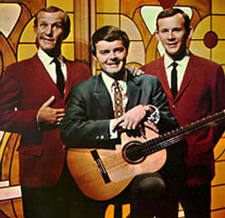

Mason Williams emerged in the late 1960s as a strong force in television and music circles. In 1968 he won two Grammy awards for his unique composition for guitar, "Classical Gas". That same year he also won an Emmy award for his work as a comedy writer on The Smothers Brothers Comedy Hour.
In the last few years Mason has concentrated on a variety of programs for his concert appearances. His Concert For Bluegrass Band And Orchestra, also titled Symphonic Bluegrass, has been performed with over 40 symphonies including such major orchestras as Denver, Kansas City, New Orleans, Oklahoma City, Louisville, and Edmonton.

Comedy
As a comedy writer, Mason has written for more than 150 hours of network television programming. Writing both music and comedy, Mason was a prime creative force for CBS' controversial Smothers Brothers Comedy Hour. Other major television personalities he has written for include Steve Martin (a writing colleague on "Smothers Brothers"), Andy Williams, Glen Campbell, Dinah Shore, Roger Miller, and Petula Clark. In 1980 Mason was head writer for NBC's Saturday Night Live.

Environmentalism
After becoming involved in protests against a Willamette River hydroelectric power project, Williams began to think of how the river itself should have a voice in its fate, and eventually collected over 400 songs about rivers, which he crafted into his program Of Time and Rivers Flowing. A chronological "river" of music and time, it encompasses the realms of classical, folk, minstrel, gospel, jazz, country, pop, and contemporary rock.

- Smiling Through – Phil Coulter

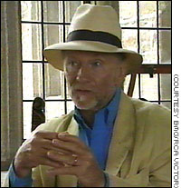

Son of a policeman in a divided town
Coulter is from Derry[, the second largest city of Northern Ireland. The two names attributed to the city have considerable significance in a divided region, and Coulter's family was acutely aware of this point of "difference", if only because his father was a policeman, one of the few Catholic members of the Royal Ulster Constabulary.
One of Phil Coulter's most popular songs, "The Town I Loved So Well", deals with the embattled city of his youth, filled with "that damned barbed wire" during The Troubles.
Coulter's father, also called Phil, encouraged music in the house. He played the fiddle while the younger Coulter's mother played the upright piano - a Challen piano, which the son recalls was "the most important piece of furniture in the house".

Education
Coulter spent his secondary school years at St. Columb's College, whose other past pupils include playwright Brian Friel, Nobel Prize winning poet Seamus Heaney, writer and literature professor Seamus Deane, author and military historian Richard Doherty, and Nobel Peace Laureate John Hume.

Beginnings of a career in music
He later studied music at the Queen's University of Belfast (QUB), but did not complete his degree. He started his first band there, playing early rock and roll music and recording two songs for a 'Rag Day' release. Coulter and a group of friends also started a Glee Club, and Coulter was playing the piano for 800 students on one memorable evening when the Beatles were performing in a nearby Belfast cinema, the Ritz. Two students were sent to talk to John Lennon and Paul McCartney, to invite them to join the Glee Club. But in the end they sent the headline performer on the tour, Helen Shapiro, one of whose songs was No. 1 in Britain at that time.
By 1964, his final year at university, Coulter had already written a couple of hit songs in Ireland and he moved to London, where his first job was as an arranger/songwriter with a music publisher in Denmark Street, London's Tin Pan Alley. This lasted a few years but was not entirely satisfying.

Songwriting partnership with Bill Martin
In the late 1960's, he formed a writing partnership with Bill Martin and from this union several memorable songs would emerge. They wrote Sandie Shaw's Eurovision Song Contest winning entry, "Puppet on a String" (1967), which went on to become an international hit with more than 100 cover versions. They had another hit in 1968 in a song for Cliff Richard called "Congratulations". The Coulter-Martin partnership lasted more than 15 years. During this time the team wrote for Dana, Richard Harris, Elvis Presley ("My Boy"), and the Bay City Rollers, for whom the team wrote nearly all of the band's hits. Coulter and Martin were also among several British musicians who contributed incidental music to the famous 1967 Spider-Man cartoon, the others including Syd Dale, Johnny Pearson and Johnny Hawksworth.

Sideman and producer
Coulter also moonlighted as a piano player and worked with such artists as Van Morrison (who gave him the 'Cool Filter' nickname), Tom Jones, Jerry Lee Lewis and the Rolling Stones. He became friends with Billy Connolly, the Scottish performer, and in the 1970's became deeply interested in Irish music, the music of his youth.
He produced three ground-breaking albums with Planxty, which had a seminal influence on modern Irish music, though the albums did not earn the artists much money. Christy Moore wrote: "He gave us a shite contract and we signed everything away. All that said, 30 years on, this album sounds good. He produced it well and ... he did have the foresight and wherewithal to record the band at a time when no one else was listening" (see [1]).
He also wrote most of the big hits for not only the Bay City Rollers, but Kenny and Slik among others during the teenybop boom of the 70's and even appeared as a production credit on "Automatic lover" by Dee D Jackson.

Going solo
In 1984 he released a solo instrumental album called Classic Tranquility that featured beloved Irish tunes. It was a national sensation. His follow-up, Sea of Tranquility, did even better, becoming the second-best selling album of all time in Ireland. He moved from London back to Ireland, where he set up a music room and office in his house in Bray, south of Dublin. He continued to record and perform around the world, notably at the White House on Saint Patrick's Day.
In 1995 the Irish Rugby Football Union asked Coulter to write a politically neutral anthem for the Ireland national rugby union team, which represents both Northern Ireland and the Republic of Ireland. The result was "Ireland's Call". At matches played in the Republic, both "Amhrán na bhFiann" (as the anthem of the host nation) and "Ireland's Call" (as the anthem of the home team) are sung. Elsewhere, "Ireland's Call" is the only anthem used.
Coulter's official website notes that he has some 23 platinum records, 39 gold and 52 silver albums. He also keeps one of the walls of his office blank, "to remind me that there’s still room for a lot more."

