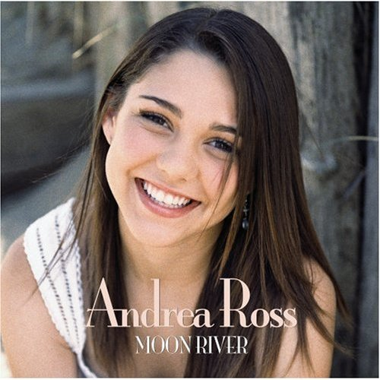
Discography

Volume I
Andrea Ross was born on April 8, 1991 in Dover, New Hampshire. She is the daughter of William Ross, an engineer and Paula (Manousos) Ross, an accounting administrator. An only child, Andrea exhibited an early flair for drama having learned to recite the alphabet in an opera-style voice at age 3. At age 4 Andrea played Rudolph the Red-Nosed Reindeer in her pre-school Christmas play. By age 6 Andrea was taking a variety of private lessons in music and dance and also trying her hand at sports. But it is was enrollment at a local performing arts after-school program that won out. Andrea progressed quickly from ensemble roles to lead musical theatre roles on-stage. Encouraged by her enthusiasm, her parents allowed her to travel to Boston to audition for a professional family theatre. Andrea won the lead role in "Tuck Everlasting" at the Wheelock Family Theatre at age 10. This was the beginning of a 5-year continuous string of winning lead roles and critical praise from the Boston-area press and theatre community.

1999-2006: Stage career

On May 23, 2005, Andrea Ross became the youngest person to receive Boston's prestigious lliot Norton Award for Outstanding Actress. In her nominating remarks on Andrea’s behalf, Terry Byrne, theatre critic of the Boston Herald commented: "Stage presence is that ineffable quality some performers have to command an audience's attention, sometimes before they even begin to speak... Combine that with considerable acting talent, a magnificent singing voice, and a strong sense of focus and the star quality is undeniable..."Andrea Ross has been a member of the Actors' Equity Association professional union since 2006. In August 2006, Andrea Ross portrayed Gabriella Montez in Disney Theatrical Productions' and Music Theater International's first granted license of the musical stage production High School Musical at Stagedoor Manor in Loch Sheldrake, New York. When Andrew Lloyd Webber introduced Andrea Ross at his Sydmonton Festival in 2005, he said: I've not heard a voice like this for a long, long time. I think she's quite extraordinary. I ask you to give a hugely warm welcome to somebody who I think you're going to hear an awful lot more of for the next . . . 50 years!”
- Moon River - Andrea Ross
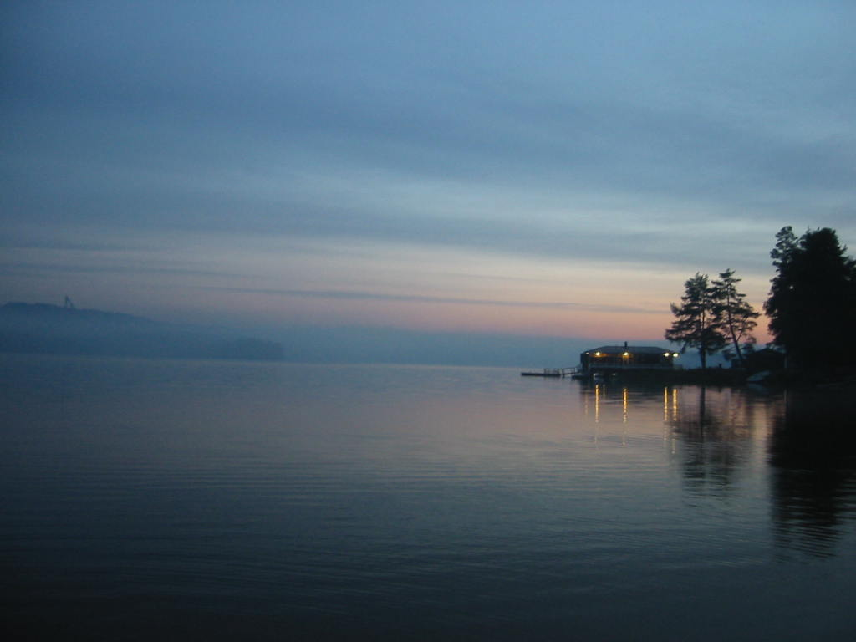
Moon river, wider than a mile,
I'm crossing you in style, some day.
Oh, dream maker, you heart breaker,
Wherever you're goin', I'm goin' your way.
Two drifters, off to see the world,
There's such a lot of world to see.
We're after the same rainbow's end,
Waitin' 'round the bend,
My huckleberry friend,
Moon river, and me!

- Whistle Down the Wind – Andrea Ross
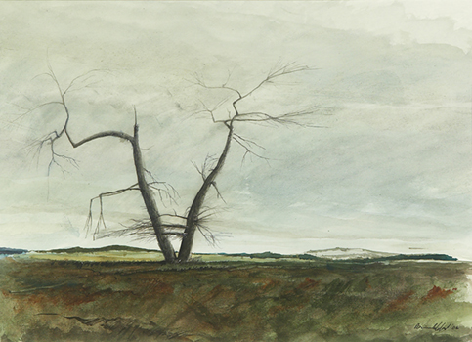

Whistle down the wind
Let your voices carry
Drown out all the rain
Light a patch of darkness
That's trechorous and scary
Howl at the stars
Whisper when you're sleeping
I'll be there to hold you
I'll be there to stop
The tears and all the weeping
Make it clear and strong
So the whole night long
Every signal that you send
Until the very end
I will not abandon you
My precious friend
So try and stem the tide
Then you'll raise a pyre
Send a flare up in the sky
Try to burn a torch
And try to build a bonfire
Every signal that you send
Until the very end I'm there
So Whistle down the wind
For I have always been right there
Howl at the stars
Whisper when you're sleeping
I'll be there to hold you
I'll be there to stop
The chills and all the weeping
Make it clear and strong
So the whole night long
Every signal that you send
Until the very end
I will not abandon you my precious friend
So Whistle Down the Wind
Let your voices carry
Drown out all the rain
Light a patch of darkness
That's trechorous and scary
Every signal that you send
Until the very end, I'm there
So Whistle Down the Wind
For I have always been right there

- White Horses - Andrea Ross

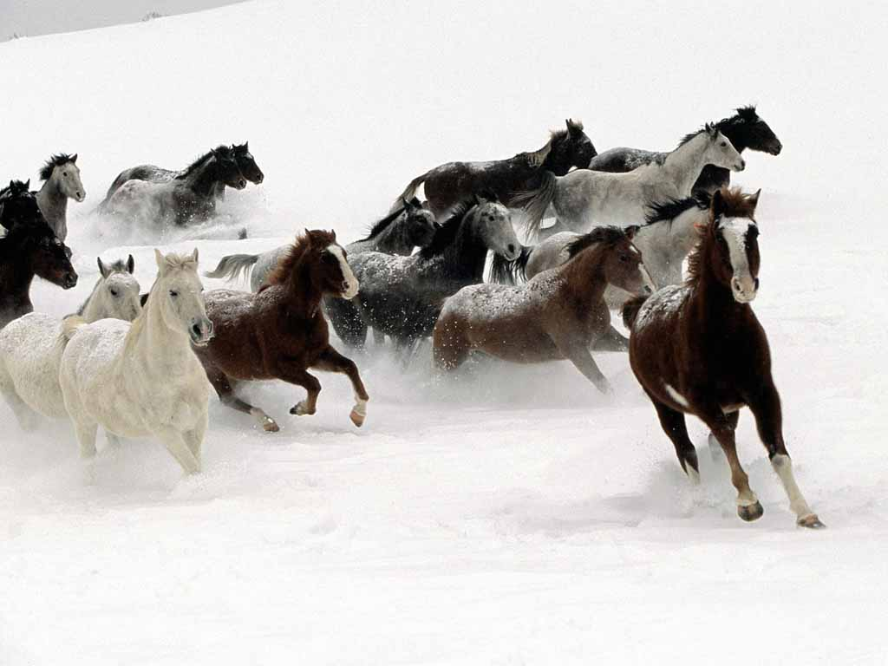
On white horses let me ride away
To my world of dreams so far away
Let me run
To the sun
To a world my heart can understand
It's a warm and gentle wonder land
Far away
Stars away
Where the clouds are made of candyfloss
As the day's born
When the stars are gone
We'll race to meet the dawn
So when I can only see the grey
Of a sad and very lonely day
That's when I
Softly sigh
On white horses
Snowy white horses
Let me ride away

- No Matter What – Andrea Ross

No matter what they tell us
No matter what they do
No matter what they teach us
What we believe is true
No matter what they call us
However they attack
No matter where they take us
We'll find our own way back
I can't deny what I believe
I can't be what I'm not
I know our love's forever
I know no matter what
If only tears were laughter
If only night was day
If only prayers were answered
And we would hear God say:
No matter what they tell you
No matter what they do
No matter what they teach you
What you believe is true
And I will keep you safe and strong
And sheltered from the storm
No matter where it's bearen
Our dream is being born
No matter who they follow
No matter who they lead
No matter how they judge us
I'll be everyone you need
No matter if the sun don't shine
Or if the skies are blue
No matter what the end is
My life began with you
I can't deny what I believe
I can't be what I'm not
I know this love's forever
That's all that matters now
No matter what



