DISCOGRAPHY VOLUME II

- No Matter What – Michael Wilson (Ross Mitchell Dance orchestra)

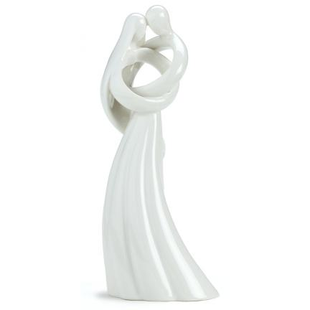
No matter what they tell us
No matter what they do
No matter what they teach us
What we believe is true
No matter what they call us
However they attack
No matter where they take us
We'll find our own way back
I can't deny what I believe
I can't be what I'm not
I know our love's forever
I know no matter what
If only tears were laughter
If only night was day
If only prayers were answered
And we would hear God say:
No matter what they tell you
No matter what they do
No matter what they teach you
What you believe is true
And I will keep you safe and strong
And sheltered from the storm
No matter where it's bearen
Our dream is being born
No matter who they follow
No matter who they lead
No matter how they judge us
I'll be everyone you need
No matter if the sun don't shine
Or if the skies are blue
No matter what the end is
My life began with you
I can't deny what I believe
I can't be what I'm not
I know this love's forever
That's all that matters now
No matter what


Popular – Andrea Ross

From the musical “Wicked”, the untold story of the Witches of Oz
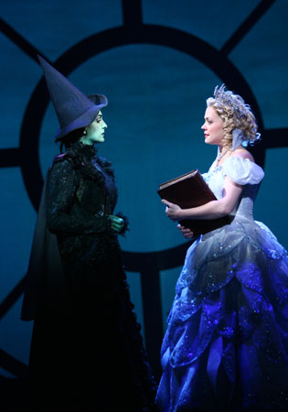
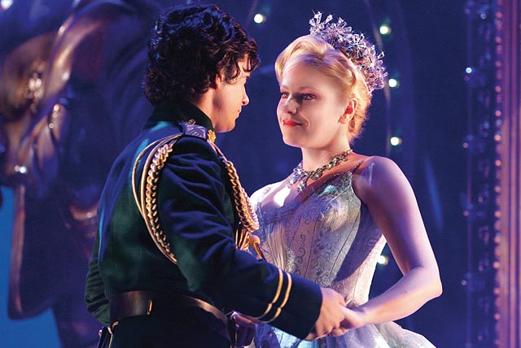
Whenever I see someone
Less fortunate than I
(And let's face it - who isn't
Less fortunate than I?)
My tender heart
Tends to start to bleed
And when someone needs a makeover
I simply have to take over
I know I know exactly what they need
And even in your case
Tho' it's the toughest case I've yet to face
Don't worry - I'm determined to succeed
Follow my lead
And yes, indeed
You will be:
Popular!
You're gonna be popular!
I'll teach you the proper ploys
When you talk to boys
Little ways to flirt and flounce
I'll show you what shoes to wear
How to fix your hair
Everything that really counts
To be popular
I'll help you be popular!
You'll hang with the right cohorts
You'll be good at sports
Know the slang you've got to know
So let's start
'Cause you've got an awfully long way to go:
Don't be offended by my frank analysis
Think of it as personality dialysis
Now that I've chosen to be come a pal, a
Sister and adviser
There's nobody wiser
Not when it comes to popular -
I know about popular
And with an assist from me
To be who you'll be
Instead of dreary who-you-were: are:
There's nothing that can stop you
From becoming popu-
Ler: lar:
La la la la
We're gonna make
You popular
When I see depressing creatures
With unprepossessing features
I remind them on their own behalf
To think of
Celebrated heads of state or
Specially great communicators
Did they have brains or knowledge?
Don't make me laugh!
They were popular! Please -
It's all about popular!
It's not about aptitude
It's the way you're viewed
So it's very shrewd to be
Very very popular
Like me!
And though you protest
Your disinterest
I know clandestinely
You're gonna grin and bear it
Your new found popularity
La la la la
You'll be popular -
Just not as quite as popular
As me!

- Heart like a Wheel – Andrea Ross

Some say the heart is just like a wheel
When you bend it you can't mend it
And my love for you is like a sinking ship
My heart is on that ship out in mid-ocean
They say that death is a tragedy
It comes once and then it's over
But my one only wish is for that deep dark abyss
For what's the use of living with no true lover
And it's only love and it's only love
That can break a human being
and turn him inside out
That can break a human being
and turn him inside out
When harm is done no love can be won
I know it happens frequently
What I can't understand please
God hold my hand
Is why it should have happened to me
And it's only love and it's only love
That can break a human being
and turn him inside out
That can break a human being
and turn him inside out
Some say the heart is just like a wheel
When you bend it you can't mend it
And my love for you is like a sinking ship
My heart is on that ship out on mid-ocean
And it's only love and it's only love
And it's only love it is only love
And it's only love it is only love
And it's only love it is only love



